Lab 06

Title
The for Loop in C++

Objective
To learn how to use a for loop in C++ to repeat a task many times.

Introduction:
A for loop is used when we want to repeat something again and again.
For example, printing numbers from 1 to 10.

Syntax

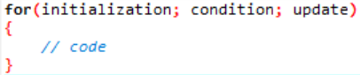

Explanation
- Initialization → start value
- Condition → check if loop should run
- Update → increase or decrease value

Program

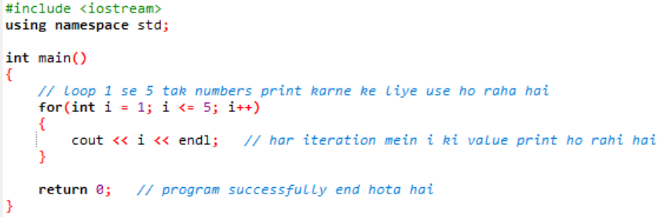

Output:
1
2
3
4
5

Conclusion:
We learned that a for loop helps us repeat code easily and saves time.

Lab 06 Tasks
1: For Loop
• Write a C++ program that uses a while loop to display numbers from 1 to
10.
• Display each number on a separate line.
Code:

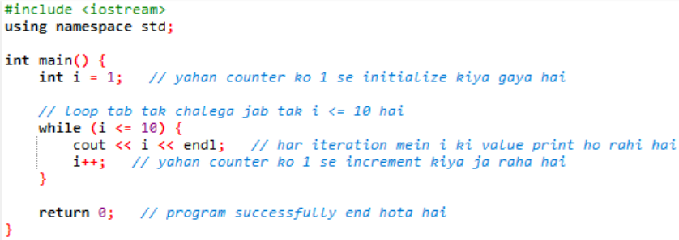

2: Nested for Loop : Multiplication Table
• Write a C++ program that generates a multiplication table from 1 to 10.
• Use nested for loops to iterate through the rows and columns of the table.
• Display the multiplication table in a formatted manner.
Code:
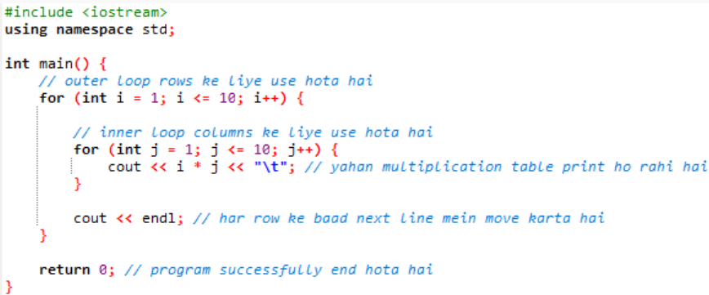
3. Sum using while Loop
- Write a C++ program that prompts the user to enter a positive integer.
- Use a for loop to calculate the sum of all numbers from 1 to the entered integer.
- Display the calculated sum.
Code:
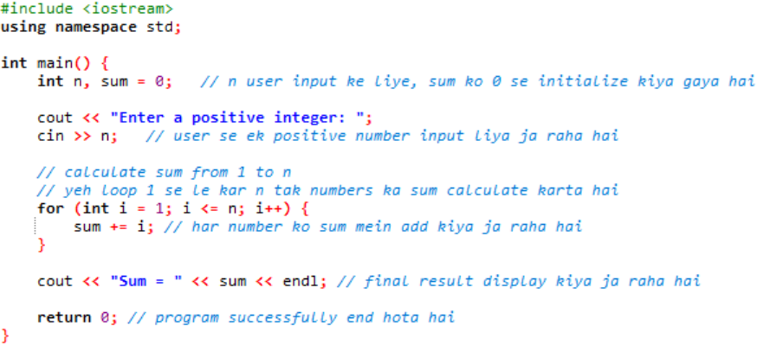
4. Nested Pattern Printing using nested for loop
- Write a C++ program that uses nested for loops to print a pattern of asterisks.
- The pattern should form a triangle shape, with each row having an increasing number of asterisks.
- The number of rows in the pattern should be determined by user input
Code:
